TABLE OF CONTENTS
CHAPTER NO. | TITLE | PAGE NO.
 | TABLE OF CONTENT  ABSTRACT  LIST OF FIGURES  LIST OF SYMBOLS | i  iv  v  vi
1. | CHAPTER 1: INTRODUCTION  - GENERAL  - OBJECTIVE  1.3 EXISTING SYSTEM  1.3.1 EXISTINGSYSTEM DISADVANTAGES  1.3.2 LITERATURE SURVEY  1.4 PROPOSED SYSTEM  1.4.1 PROPOSED SYSTEM ADVANTAGES | 1  2  3  3  4  10
2. | CHAPTER 2: PROJECT DESCRIPTION  2.1 GENERAL  2.2 METHODOLOGIES  2.2.1 MODULES NAME  2.2.2 MODULES EXPLANATION  2.2.3 MODULE DIAGRAM  2.2.4 GIVEN INPUTAND EXPECTED OUTPUT  2.3 TECHNIQUE OR ALGORITHM | 11  12  12  13  13  13  14
3. | CHAPTER 3: REQUIREMENTS  3.1 General  3.2 Hardware REQUIREMENTS  3.3 Software REQUIREMENTS | 15  16  17
4. | CHAPTER 4: SYSTEM DESIGN  4.1 general  4.1.1 activity diagram  4.1.2 USE CASE DIAGRAM  4.1.3 DATA FLOW DIAGRAM  4.1.4 SEQUENCE DIAGRAM  4.1.5 COLLABORATION DIAGRAM  4.1.6 CLASS DIAGRAM  4.1.7 SYSTEM ARCHITECTURE  4.1.8 OBJECT DIAGRAM  4.1.9 STATE DIAGRAM  4.1.10 COMPONENT DIAGRAM  4.1.11 E-R DIAGRAM  4.2 DATABASE DESIGN (ALL LEVEL | 18  19  20  21  22  23  24  25  26  27  28  29  30
5. | CHAPTER 5: SOFTWARE SPECIFICATION  5.1 general | 31
6. | CHAPTER 6: IMPLEMENTATION  6.1 GENERAL  6.2 IMPLEMENTATIOn | 34

7. | CHAPTER 7: SNAPSHOTS  7.1 GENERAL  7.2 VARIOUS SNAPSHOTS | 36
8. | CHAPTER 8: SOFTWARE TESTING  8.1 GENERAL  8.2 DEVELOPING METHODOLOGIES  8.3 TYPES OF TESTING | 38  39  40
9. | CHAPTER 9: APPLICATIONS &  FUTURE ENHANCEMENT  9.1 GENERAL  9.2 APPLICATIONS  9.3 FUTURE ENHANCEMENTS | 41
10 | CHAPTER 10: CONCLUSION  10.1CONCLUSION  10.2 REFERENCES | 42  43

DNA SEQUENCE PREDICTIONS USING NLP AND ML
ABSTRACT:

Deoxyribonucleic acid (DNA) is a biological macromolecule. Its main function is information storage. At present, the advancement of sequencing technology had caused DNA sequence data to grow at an explosive rate, which has also pushed the study of DNA sequences in the wave of big data. Moreover, machine learning is a powerful technique for analyzing largescale data and learns spontaneously to gain knowledge. It has been widely used in DNA sequence data analysis and obtained a lot of research achievements. Firstly, the review introduces the development process of sequencing technology, expounds on the concept of DNA sequence data structure and sequence similarity. Then we analyze the basic process of data mining, summary several major machine learning algorithms like Multinomial NB Classifier & Random Forest, and put forward the challenges faced by machine learning algorithms in the mining of biological sequence data and possible solutions in the future. Then we review four typical applications of machine learning in DNA sequence data: DNA sequence alignment, DNA sequence classification, DNA sequence clustering, and DNA pattern mining. We analyze their corresponding biological application background and significance, and systematically summarized the development and potential problems in the field of DNA sequence data mining using Multinomial NB Classifier & Random Forest. Finally, we summarize the content of the review and look into the future of some research directions for the next step.

LIST OF FIGURES

FIGURE NO | NAME OF THE FIGURE | PAGE NO.
4.2 | Activity Diagram | 30
4.3 | Use case Diagram | 31
4.4 | Data flow diagram | 32
4.5 | Sequence diagram | 33
4.6 | Collaboration diagram | 34
4.7 | Class diagram | 35
4.8 | Architecture Diagram | 36
4.9 | State Diagram | 37
4.1 | Component Diagram | 38

LIST OF SYSMBOLS

S.NO | NOTATION  NAME | NOTATION | DESCRIPTION
1. | Class | Class Name  -attribute  -attribute  +operation  +operation  +operation  + public  -private  # protected | Represents a collection of similar entities grouped together.
2. | Association | name  Class B  Class A  Class A  Class B | Associations represents static relationships between classes. Roles represents the way the two classes see each other.
3. | Actor | Class A  Class A  Class B  Class B | It aggregates several classes into a single classes.
4. | Aggregation | Class A  Class A  Class B  Class B | Interaction between the system and external environment

5. | Relation  (uses) | uses | Used for additional process communication.
6. | Relation  (extends) | extends | Extends relationship is used when one use case is similar to another use case but does a bit more.
7. | Communication |  | Communication between various use cases.
8. | State | State | State of the processes.
9. | Initial State |  | Initial state of the object
10. | Final state |  | Final state of the object
11. | Control flow |  | Represents various control flow between the states.
12. | Decision box |  | Represents decision making process from a constraint
13. | Use case | Uses case | Interact ion between the system and external environment.
14. | Component |  | Represents physical modules which are a collection of components.
15. | Node |  | Represents physical modules which are a collection of components.
16. | Data Process/State |  | A circle in DFD represents a state or process which has been triggered due to some event or action.
17. | External entity |  | Represents external entities such as keyboard, sensors, etc.
18. | Transition |  | Represents communication that occurs between processes.
19. | Object Lifeline |  | Represents the vertical dimensions that the object communications.

CHAPTER-1
INTRODUCTION
1
1.Introduction :
We live in the era of the genome, advances in science have allowed humans to spy on the mysteries of life. In recent decades, the rapid expansion of biological data is a significant feature of the development of molecular biology, and a massive biological information database has rapidly formed. We must obtain useful knowledge from these huge data, and simultaneously bioinformatics was born. Bioinformatics is an interdisciplinary subject. It comprehensively uses mathematics, life sciences, and computer science to mine biological information in biological data (Chu, 2014), and further guides the relevant researches of biological researchers Specifically, the first step is to obtain information on the protein coding region by analyzing the genomic DNA sequence. Then simulating and predicting the spatial structure of the protein.
Finally, according to the function of the protein, the researchers make the necessary drug design. According to statistics, the amount of biological data approximately doubles every 18 months. In 1982, GenBank’s first nucleic acid sequence database had only 606 sequences, containing 680,000 nucleotide bases (Bilofsky et al., 1986). As of February 2013, its database already contains 162 million biological sequence data, containing 150 billion nucleotide bases. How to mine knowledge from these huge data and guide biological research s an important research content of bioinformatics.
For complex biological data, on the one hand, it is necessary to solve the problem of storage and management of massive data, and on the one hand, it is necessary to extract effective information from the data on the premise of ensuring that the data reflects the true meaning of biology. Machine learning is an important method to achieve artificial intelligence. It can handle the automatic learning of machines without explicit programming and has been widely used in the field of bioinformatics

1.2 OBJECTIVE

Sequence similarity is the basis of sequence data mining, and it is a research direction where sequence similarity bioinformatics is very meaningful. Sequence similarity refers to the degree of similarity between sequences. If the similarity between two sequences exceeds 30%, it is considered that they may have homology. The homologous sequences have a common evolutionary ancestor, and their structures and functions may have similarities.

1.3 EXISTING SYSTEM:
- A vast amount of sequence data has been generated due to advancements in DNA sequencing technology. This exponential increase requires new and efficient methods for the analysis of DNA sequence data. Predicting genes in this newly sequenced data is an important and essential step towards genome annotation. Genome annotation helps in determining function of these genes.
- Accurate splice site prediction in DNA sequences leads to correct gene structure prediction in eukaryotes and it requires effective modelling of regions surrounding these sites. A large number of methods for splice site prediction are available in literature but very few of them are suitable to be incorporated as gene prediction module because of their complexity. In this paper, a splice site prediction method based on second order markov model and support vector machine is developed.
DRAWBACKS:
- It does not execute very well when the data set has more sound i.e. target classes are overlapping.
- It doesn't perform well when we have large data set because the required training time is higher.
- In cases where the number of features for each data point exceeds the number of training data samples, the SVM will underperform.

1.4 LITERATURE SURVEY
Title: ML- DSP: Machine Learning with Digital Signal Processing for ultrafast, accurate, and scalable genome classification at all taxonomic levels
Author: Kathleen A. Hill, Lila Kari, Gurjit S. Randhawa
Year: 2020
Description:
Background: Although software tools abound for the comparison, analysis, identification, and classification of genomic sequences, taxonomic classification remains challenging due to the magnitude of the datasets and the intrinsic problems associated with classification. The need exists for an approach and software tool that addresses the limitations of existing alignment-based methods, as well as the challenges of recently proposed alignment-free methods.
Results: We propose a novel combination of supervised Machine Learning with Digital Signal Processing, resulting in ML-DSP: an alignment-free software tool for ultrafast, accurate, and scalable genome classification at all taxonomic levels. We test ML-DSP by classifying 7396 full mitochondrial genomes at various taxonomic levels, from kingdom to genus, with an average classification accuracy of >97%. A quantitative comparison with state-of-the-art classification software tools is performed, on two small benchmark datasets and one large 4322 vertebrate mtDNA genomes dataset. Our results show that ML-DSP overwhelmingly outperforms the alignment-based software MEGA7 (alignment with MUSCLE or CLUSTALW) in terms of processing time, while having comparable classification accuracies for small datasets and superior accuracies for the large dataset. Compared with the alignment-free software FFP (Feature Frequency Profile), ML-DSP has significantly better classification accuracy, and is overall faster. We also provide preliminary experiments indicating the potential of ML-DSP to be used for other datasets, by classifying 4271 complete dengue virus genomes into subtypes with 100% accuracy, and 4,710 bacterial genomes into phyla with 95.5% accuracy. Lastly, our analysis shows that the "Purine/Pyrimidine", "Just-A" and "Real" numerical representations of DNA sequences outperform ten other such numerical representations used in the Digital Signal Processing literature for DNA classification purposes.
Conclusions: Due to its superior classification accuracy, speed, and scalability to large datasets, ML-DSP is highly relevant in the classification of newly discovered organisms, in distinguishing genomic signatures and identifying their mechanistic determinants, and in evaluating genome integrity.

Title: Neural Networks for Genome Signature Analysis
Author: Lois Boggess, Liangyou Chen
YEAR:2020
Description: Neural networks show promise for mitigating the combinatorial explosion in genomic data. Researchers are interested in the applicability of neural networks for the design of automatic genomic analysis tools. This: paper describes the application of a variety of neural network models, including back-propagation, radial basis function networks, self-organizing maps, and committee machines, to the problem of gene classification using genome signatures. Results shows that in a two-way classification problem, average accuracies of 97% can be attained with these models, while for a more difficult four-way classification task average accuracy was more than 83%. Methods for developing the training and test data for the signature problem are discussed, as well as modifications to the general algorithms of the neural network models.

Title: Graphical classification of DNA sequences of HLA alleles by deep learning
Author: Yuhei Kaneshita, Satoshi Asatani, Seiichi Tagawa, Hirohiko Niioka, Takashi Hirano, Jun Miyake,
Year: 2021
Description: Alleles of human leukocyte antigen (HLA)-A DNAs are classified and expressed graphically by using artificial intelligence “Deep Learning (Stacked autoencoder)”. Nucleotide sequence data corresponding to the length of 822 bp, collected from the Immuno Polymorphism Database, were compressed to 2-dimensional representation and were plotted. Profiles of the two-dimensional plots indicate that the alleles can be classified as clusters are formed. The two-dimensional plot of HLA-A DNAs gives a clear outlook for characterizing the various alleles.

Title: Large-scale Machine Learning for Metagenomics Sequence Classification .
Author: H. Rowley, S. Baluja, and T. Kanade.,
Year: 2020
Description: Motivation: Metagenomics characterizes the taxonomic diversity of microbial communities by sequencing DNA directly from an environmental sample. One of the main challenges in metagenomics data analysis is the binning step, where each sequenced read is assigned to a taxonomic clade. Because of the large volume of metagenomics datasets, binning methods need fast and accurate algorithms that can operate with reasonable computing requirements. While standard alignment-based methods provide state-of-the-art performance, compositional approaches that assign a taxonomic class to a DNA read based on the k-mers it contains have the potential to provide faster solutions

Title: Classification of DNA microarrays using artificial neural networks and ABC algorithm
Author: R. E. Schapire, Y. Freund, P. Bartlett, and W. S. Lee,
Year: 2019
Description: DNA microarray is an efficient new technology that allows to analyze, at the same time, the expression level of millions of genes. The gene expression level indicates the synthesis of different messenger ribonucleic acid (mRNA) molecule in a cell. Using this gene expression level, it is possible to diagnose diseases, identify tumors, select the best treatment to resist illness, detect mutations among other processes. In order to achieve that purpose, several computational techniques such as pattern classification approaches can be applied. The classification problem consists in identifying different classes or groups associated with a particular disease (e.g., various types of cancer, in terms of the gene expression level). However, the enormous quantity of genes and the few samples available, make difficult the processes of learning and recognition of any classification technique. Artificial neural networks (ANN) are computational models in artificial intelligence used for classifying, predicting and approximating functions. Among the most popular ones, we could mention the multilayer perceptron (MLP), the radial basis function neural network (RBF) and support vector machine (SVM). The aim of this research is to propose a methodology for classifying DNA microarray. The proposed method performs a feature selection process based on a swarm intelligence algorithm to find a subset of genes that best describe a disease. After that, different ANN are trained using the subset of genes. Finally, four different datasets were used to validate the accuracy of the proposal and test the relevance of genes to correctly classify the samples of the disease..

1.5 PROPOSED SYSTEM
- DNA sequence expresses many information about species which are behaviors, appearance, their parent’s information etc. Those information helps to identify a species separately form other species. Therefore, identifying the DNA Sequence order and their classification is significant need in today. Nowadays the Genetic expression is used frequently in medical sector. It applies to recognize the cancers, down syndrome, mutations, tumors etc.
- The goal of DNA sequencing is identifying the order of nucleotides of a given DNA section. We analyze their corresponding biological application background and significance, and systematically summarized the development and potential problems in the field of DNA sequence data mining using Multinomial NB Classifier & Random Forest and got an highest accuracy of 98.4%..
ADVANTAGES: -
- It is easy to implement as you only have to calculate probability.
- Used for both continuous and discrete data.
- It is highly scalable and can easily handle large datasets

CHAPTER 2
PROJECT DESCRIPTION
2.1 GENERAL:
The main mining modes of machine learning include data characterization and differentiation, data frequent patterns, association and correlation, classification and regression of data predictive analysis, cluster analysis, and outlier analysis. Data mining for DNA sequences is generally carried out from these aspects, and research in these areas is inseparable from similarity analysis between sequences (Pearson, 2013). It can be seen that sequence similarity is the basis of DNA sequence data mining.
Sequence similarity means that there are similar or identical sites between sequences. The sequence similarity can be a quantitative value or a qualitative description. If the degree of similarity between two sequences exceeds 30%, It is considered that the two sequences have a homologous relationship. Therefore, if the two sequences are highly similar, the two sequences are likely to have a common evolutionary ancestor. At the same time, if a sequence similar to the unknown sequence can be found from the sequences with known functions, we can further predict the function (Rogozin et al., 1996) of the unknown sequence.

2.2 METHODOLOGIES
2.2.1MODULES NAME:

- Classification of Biomedical Data and Prediction.
When considering the issues, there is an issue in the classification of biomedical data and the prediction of those data. It is about find a unique assessment metric for above classification and for the prediction [10]. This is a difficult task can be seen in this study area. Data cleaning. Because of the increasing amount of heterogeneous data, data sets often have missing data and inconsistent data. Low data quality will have a serious negative impact on the information extraction process. Therefore, deleting incomplete, or inconsistent data is the first step in data mining
- Storage of DNA Sequencing Data.
There is another issue with storage of large amount of DNA sequencing data. These data should be storage in a proper way and if it is stored like that, then it would be easy to access those data. As well as it should be reliable to access [20].If the data is meaningless, there isnotany available data. So that, it is very important fact to be concerned. Data integration. If the source of the data to be studied is different, it must be aggregated consistently
- Binary Nonlinear Classification Issue.
When examine the issues, there is an issue with the DNA sequence classification. It can be recognized as the binary nonlinear classification issue [24]. Binary classification is also called as binomial classification which means the classification of given elements set into two distinct groups based on the classification rule. Data selection. Accurately select relevant data based on the research content
- DNA Sequence Length Normalization.
There can be see another issue in DNA sequence length normalization. Normally genomes are different in their length and length normalization usually results in adding which is called as up-sampling or losing which is known as down-sampling, some of information [22]. This may be made problems when dealing with the subset of genomes and lager genome sequence. Data conversion. Transform or merge data into a form suitable for mining, and integrate new attributes or functions useful for the data mining process
E. Binning Step
When considering the issues, binning step is the one of main difficult task that happen in analyzing the metagenomic data. It happens in the process of assigning the sequenced read to a taxonomic clade [16]. Binning method must be faster and also accurate when dealing with large amount of metagenomic datasets. This is also a challenge. F. Problems in Support Vector Machine Learning. There are some problems in Support Vector Machine Learning. One of them is convex optimization issues [1] which is arise in the research conducted by Qingshan Jiang, Dan Wei, Qingda Zhou. Another one is detecting problem [3] and it is in the research conducted by Shailendra Singh, Trilok Chand Aseri, Neelam Goel. In here they used Support Vector Machine Learning along with the markov model G. Optimization Problem Optimization problem is arisen in the analyzing process of genome. As a solution to this problem Genetic Algorithm was introduced by John Holland in 1975 [26]. It is a computing search technique. GA used evolution principles found in nature to solve the problem of finding an optimal solution. Data mining. Select the appropriate model according to the problem and make subsequent improvements; 6. Mode evaluation. After acquiring knowledge from the data, select appropriate indicators to evaluate the model.
2.3 TECHNIQUE USED OR ALGORITHM USED
2.3.1 EXISTING TECHNIQUE: -
Support Vector Machine (SVM)
Markov chain models and SVM are well established methods and have been successfully used in the field of bioinformatics to solve various problems. Their use in the field of splice site prediction is not new. The individual application of these methods for splice site prediction doesn’t give satisfactory results. However, the results can be improved by combining these methods. In most of the previous attempts where SVM is employed for classification, the DNA sequence data is directly provided as input through binary encoding scheme. These classifiers are not able to distinguish between true and false sites which suggest that SVM need more powerful information modeling approach than simply the sequence data.
2.3.2 PROPOSED TECHNIQUE: -
Multinomial NB Classifier
The multinomial Naive Bayes classifier is suitable for classification with discrete features (e.g., word counts for text classification). The multinomial distribution normally requires integer feature counts. However, in practice, fractional counts such as tf-idf may also work.it is a Bayesian learning approach popular in Natural Language Processing (NLP). The program guesses the tag of a text, such as an email or a newspaper story, using the Bayes theorem. It calculates each tag's likelihood for a given sample and outputs the tag with the greatest chance.

CHAPTER 3
REQUIREMENTS ENGINEERING
3.1 GENERAL
The interpretation of the handwriting character by developing techniques and methods such as improvement of character classification techniques. The accurate and rapid classification for accurate information retrieval, sound classification, stock price forecasting.
3.2 HARDWARE REQUIREMENTS
The hardware requirements may serve as the basis for a contract for the implementation of the system and should therefore be a complete and consistent specification of the whole system. They are used by software engineers as the starting point for the system design. It shouls what the system do and not how it should be implemented.

Processor - Pentium –IV
- Speed - 1.1 GHz
- Ram - 256 MB
- Hard Disk - 20 GB
- Key Board - Standard Windows Keyboard
- Mouse - Two or Three Button Mouse
- Monitor - SVGA

3.3 SOFTWARE REQUIREMENTS
The software requirements document is the specification of the system. It should include both a definition and a specification of requirements. It is a set of what the system should do rather than how it should do it. The software requirements provide a basis for creating the software requirements specification. It is useful in estimating cost, planning team activities, performing tasks and tracking the teams a nd tracking the team’s progress throughout the development activity.

SOFTWARE REQUIREMENTS
- Operating System - Windows xp/7/10
- Coding Language - Python
- IDE - Spyder3

3.4 FUNCTIONAL REQUIREMENTS
Chest X-ray and CT are widely used in the screening and diagnosis of COVID-19.it is important to employ a contactless and automated image acquisition workflow to avoid the severe risks of infection during COVID-19 pandemic. However, the conventional imaging workflow includes inevitable contact between technicians and patients. Many modern X-ray and CT systems are equipped with cameras for patient monitoring purposes. During the outbreak of COVID-19, those devices facilitate the implementation of a contactless scanning workflow.
3.5 NON-FUNCTIONAL REQUIREMENTS
The major non-functional Requirements of the system are as follows
Usability
The system is designed with completely automated process hence there is no or less user intervention.
Reliability
The system is more reliable because of the qualities that are inherited from the chosen platform java. The code built by using python is more reliable.
Performance
This system is developing in the high-level languages and using the advanced front-end and back-end technologies it will give response to the end user on client system with in very less time.
Supportability
The system is designed to be the cross platform supportable. The system is supported on a wide range of hardware and any software platform, which is built into the system.
Implementation
The system is implemented in web environment using Flask framework. The server is used as the web server and windows xp professional is used as the platform. Interface the user interface is based on Flask provides web application.

CHAPTER 4
DESIGN ENGINEERING
4.1 GENERAL

Design Engineering deals with the various UML [Unified Modeling language] diagrams for the implementation of project. Design is a meaningful engineering representation of a thing that is to be built. Software design is a process through which the requirements are translated into representation of the software. Design is the place where quality is rendered in software engineering. Design is the means to accurately translate customer requirements into finished product.

4.2 UML DIAGRAMS
4.2.1 USE CASE DIAGRAM

EXPLANATION:
The main purpose of a use case diagram is to show what system functions are performed for which actor. Roles of the actors in the system can be depicted. The above diagram consists of user as actor. Each will play a certain role to achieve the concept.
4.2.2 CLASS DIAGRAM

EXPLANATION
In this class diagram represents how the classes with attributes and methods are linked together to perform the verification with security. From the above diagram shown the various classes involved in our project.

4.2.3 OBJECT DIAGRAM

EXPLANATION:
In the above diagram tells about the flow of objects between the classes. It is a diagram that shows a complete or partial view of the structure of a modeled system. In this object diagram represents how the classes with attributes and methods are linked together to perform the verification with security.

4.2.8 STATE DIAGRAM

EXPLANATION:
State diagram is a loosely defined diagram to show workflows of stepwise activities and actions, with support for choice, iteration and concurrency. State diagrams require that the system described is composed of a finite number of states; sometimes, this is indeed the case, while at other times this is a reasonable abstraction. Many forms of state diagrams exist, which differ slightly and have different semantics.
4.2.9 ACTIVITY DIAGRAM

EXPLANATION:
Activity diagrams are graphical representations of workflows of stepwise activities and actions with support for choice, iteration and concurrency. In the Unified Modeling Language, activity diagrams can be used to describe the business and operational step-by-step workflows of components in a system. An activity diagram shows the overall flow of control.

4.2.6 SEQUENCE DIAGRAM

EXPLANATION:
A sequence diagram in Unified Modeling Language (UML) is a kind of interaction diagram that shows how processes operate with one another and in what order. It is a construct of a Message Sequence Chart. A sequence diagram shows object interactions arranged in time sequence. It depicts the objects and classes involved in the scenario and the sequence of messages exchanged between the objects needed to carry out the functionality of the scenario.

4.2.7 COLLABORATION DIAGRAM

EXPLANATION:
A collaboration diagram, also called a communication diagram or interaction diagram, is an illustration of the relationships and interactions among software objects in the Unified Modeling Language (UML). The concept is more than a decade old although it has been refined as modeling paradigms have evolved.

4.2.4 COMPONENT DIAGRAM

EXPLANATION

In the Unified Modeling Language, a component diagram depicts how components are wired together to form larger components and or software systems. They are used to illustrate the structure of arbitrarily complex systems. User gives main query and it converted into sub queries and sends through data dissemination to data aggregators. Results are to be showed to user by data aggregators. All boxes are components and arrow indicates dependencies.

4.2.5 DEPLOYMENT DIAGRAM

EXPLANATION:
Deployment Diagram is a type of diagram that specifies the physical hardware on which the software system will execute. It also determines how the software is deployed on the underlying hardware. It maps software pieces of a system to the device that are going to execute it.

Data Flow Diagram
Level 0
analyze Human & animal’s dataset
Dataset Input
select Human & animal’s dataset
Define path

Level 1
Predictions
Analysis
DNA Sequence Predictions
Pre-processing
Multinomial NB

SYSTEM ARCHITECTURE:

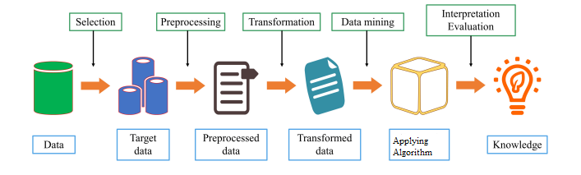

Fig. Proposed Methodology
CHAPTER 5
DEVELOPMENT TOOLS
Python
Python is a high-level, interpreted, interactive and object-oriented scripting language. Python is designed to be highly readable. It uses English keywords frequently where as other languages use punctuation, and it has fewer syntactical constructions than other languages.

History of Python
Python was developed by Guido van Rossum in the late eighties and early nineties at the National Research Institute for Mathematics and Computer Science in the Netherlands.
Python is derived from many other languages, including ABC, Modula-3, C, C++, Algol-68, Smalltalk, and Unix shell and other scripting languages.
Python is copyrighted. Like Perl, Python source code is now available under the GNU General Public License (GPL).
Python is now maintained by a core development team at the institute, although Guido van Rossum still holds a vital role in directing its progress.

Importance of Python
- Python is Interpreted − Python is processed at runtime by the interpreter. You do not need to compile your program before executing it. This is similar to PERL and PHP.
- Python is Interactive − You can actually sit at a Python prompt and interact with the interpreter directly to write your programs.
- Python is Object-Oriented − Python supports Object-Oriented style or technique of programming that encapsulates code within objects.
- Python is a Beginner's Language − Python is a great language for the beginner-level programmers and supports the development of a wide range of applications from simple text processing to WWW browsers to games.

Features of Python
- Easy-to-learn − Python has few keywords, simple structure, and a clearly defined syntax. This allows the student to pick up the language quickly.
- Easy-to-read − Python code is more clearly defined and visible to the eyes.
- Easy-to-maintain − Python's source code is fairly easy-to-maintain.
- A broad standard library − Python's bulk of the library is very portable and cross-platform compatible on UNIX, Windows, and Macintosh.
- Interactive Mode − Python has support for an interactive mode which allows interactive testing and debugging of snippets of code.
- Portable − Python can run on a wide variety of hardware platforms and has the same interface on all platforms.
- Extendable − You can add low-level modules to the Python interpreter. These modules enable programmers to add to or customize their tools to be more efficient.
- Databases − Python provides interfaces to all major commercial databases.
- GUI Programming − Python supports GUI applications that can be created and ported to many system calls, libraries and windows systems, such as Windows MFC, Macintosh, and the X Window system of Unix.
- Scalable − Python provides a better structure and support for large programs than shell scripting.
Apart from the above-mentioned features, Python has a big list of good features, few are Listed below −
- It supports functional and structured programming methods as well as OOP.
- It can be used as a scripting language or can be compiled to byte-code for building large applications.
- It provides very high-level dynamic data types and supports dynamic type checking.
- IT supports automatic garbage collection.
- It can be easily integrated with C, C++, COM, ActiveX, CORBA, and Java.
Libraries used in python:
- numpy - mainly useful for its N-dimensional array objects.
- pandas - Python data analysis library, including structures such as dataframes.
- matplotlib - 2D plotting library producing publication quality figures.
- scikit-learn - the machine learning algorithms used for data analysis and data mining tasks.
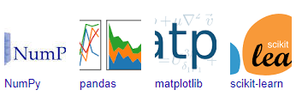
Figure: NumPy, Pandas, Matplotlib, Scikit-learn

CHAPTER 6
IMPLEMENTATION
6.1 GENERAL
CODING: 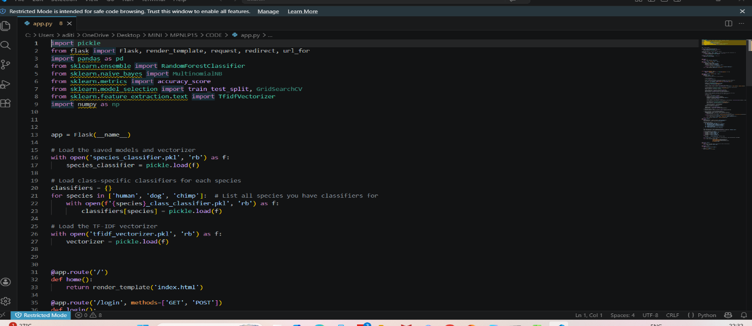

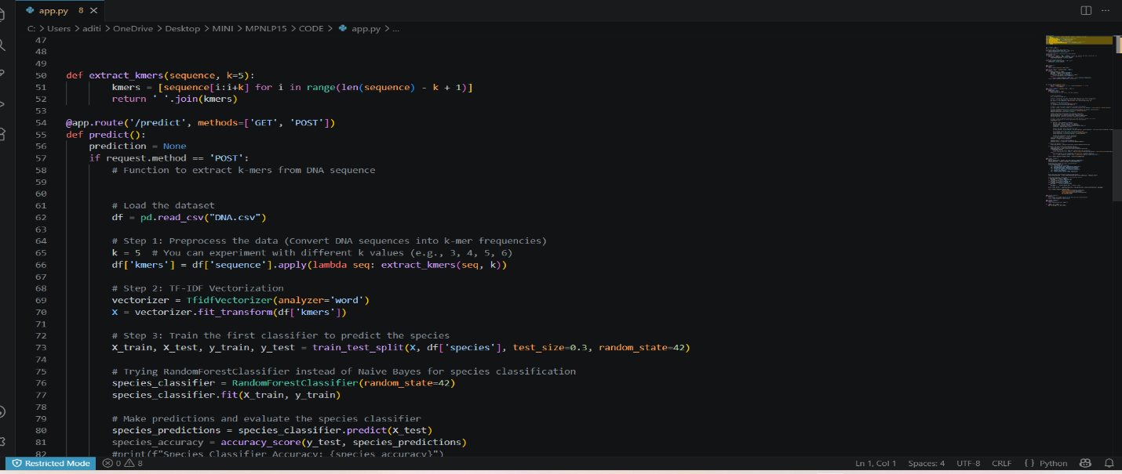
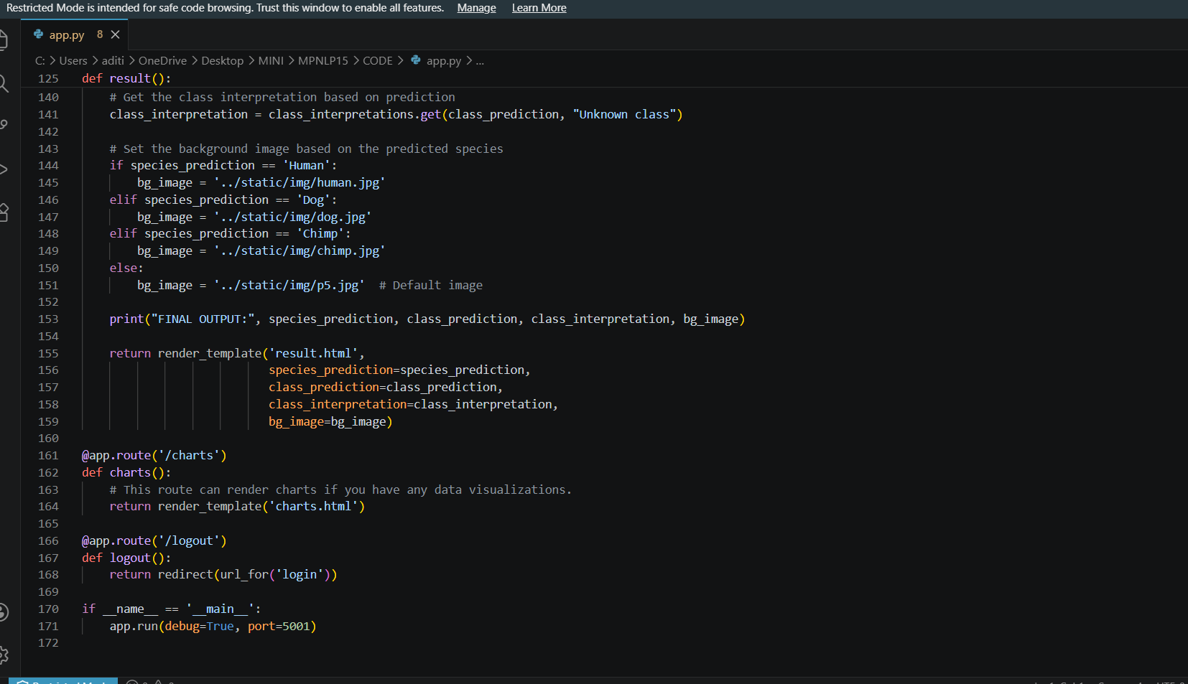

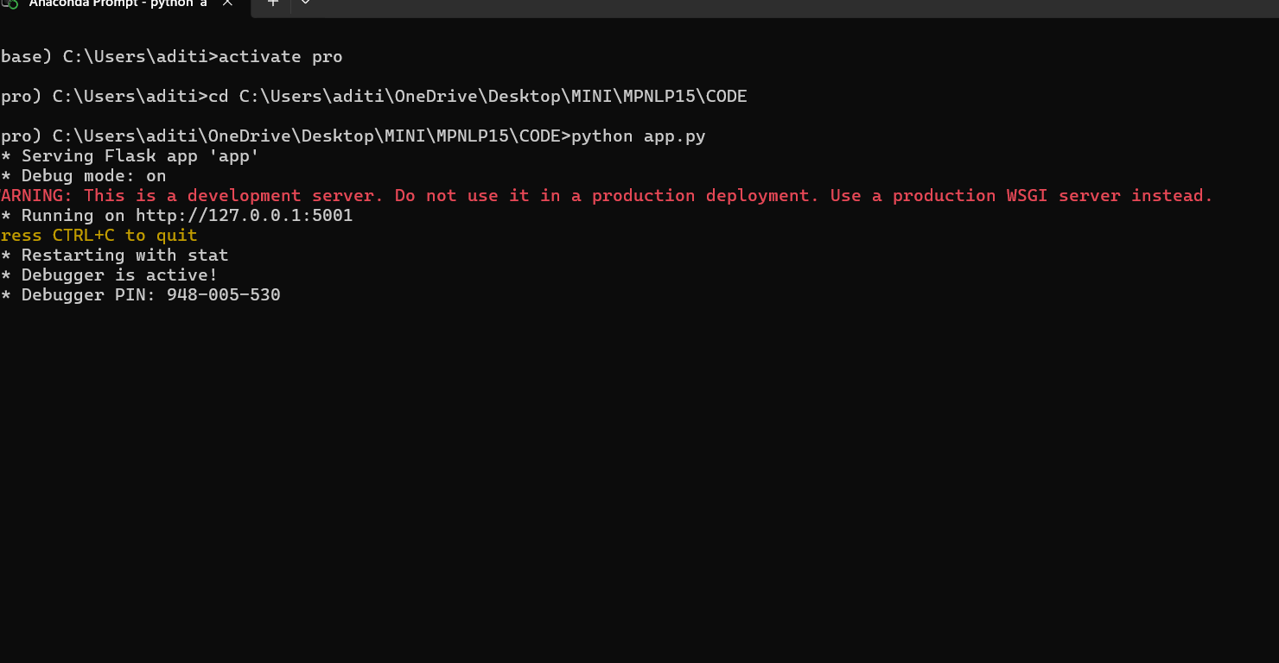
CHAPTER 7
SNAPSHOTS
7.1 SNAPSHOTS
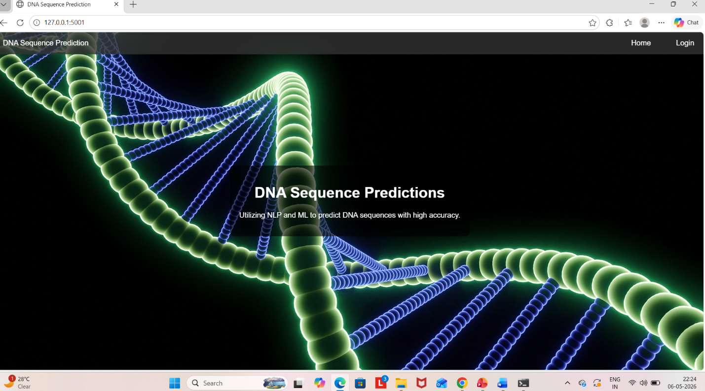
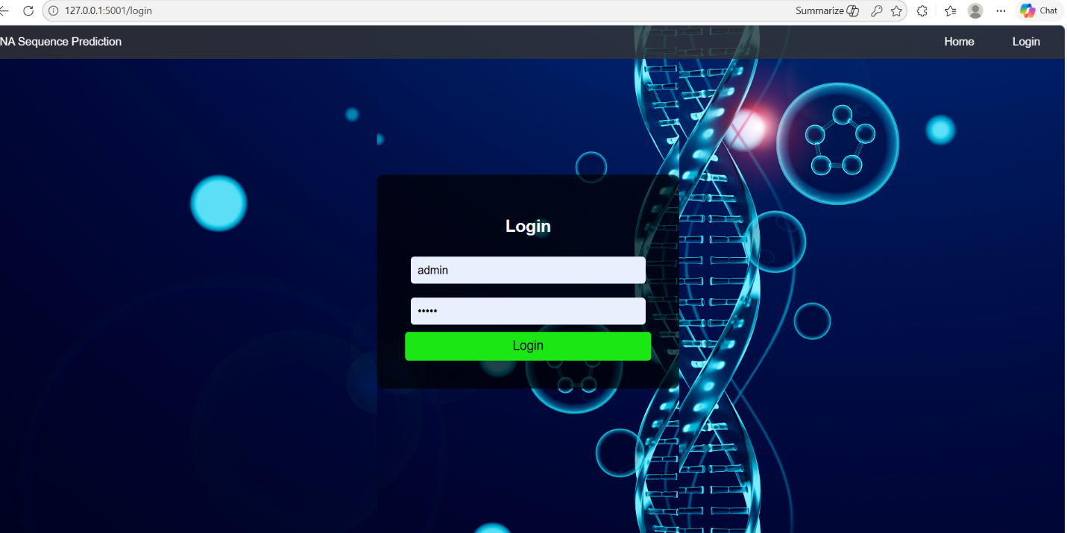

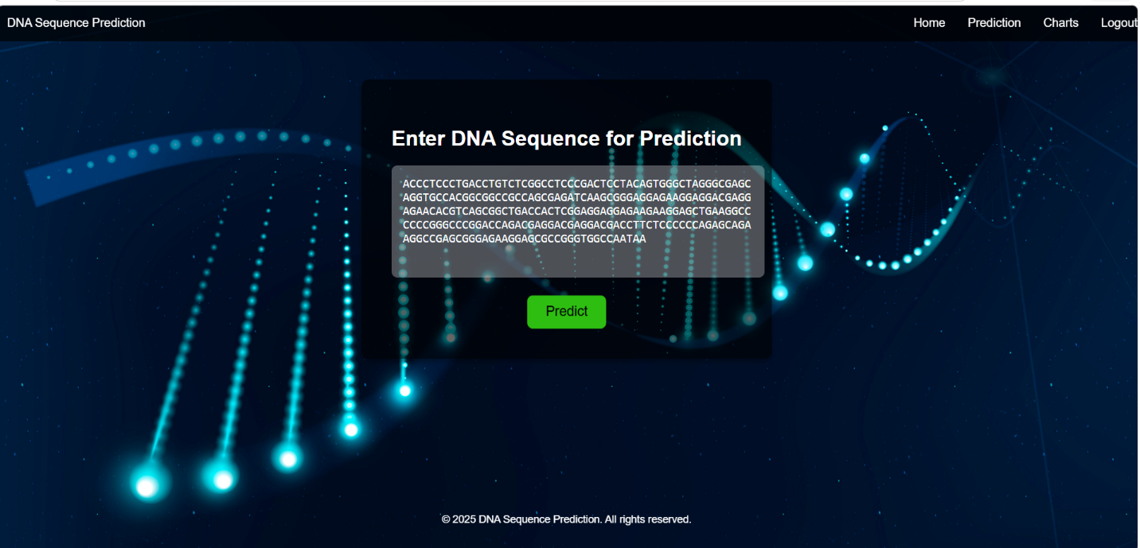

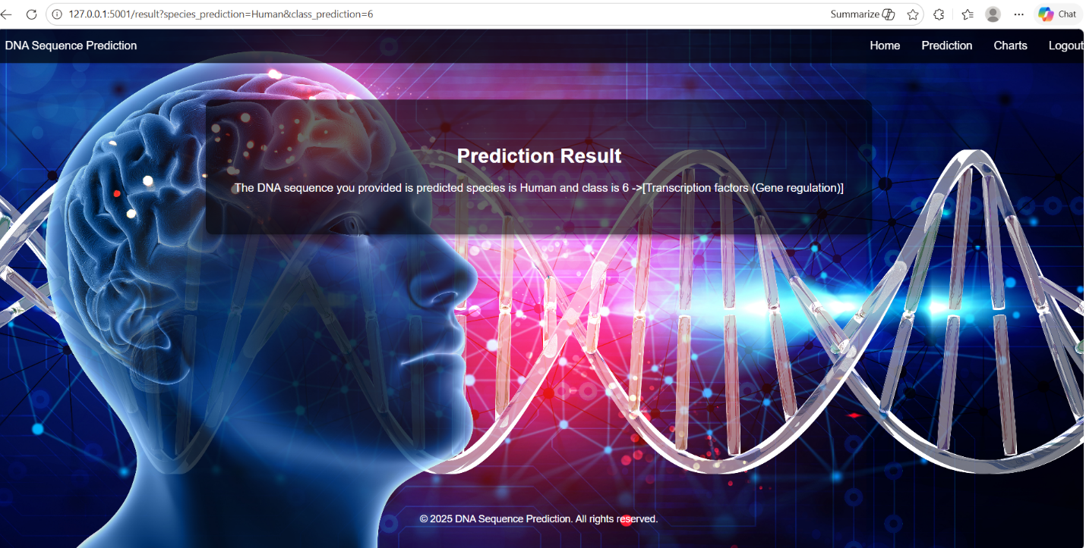
CHAPTER 8
SOFTWARE TESTING

8.1 GENERAL
The purpose of testing is to discover errors. Testing is the process of trying to discover every conceivable fault or weakness in a work product. It provides a way to check the functionality of components, sub-assemblies, assemblies and/or a finished product It is the process of exercising software with the intent of ensuring that the Software system meets its requirements and user expectations and does not fail in an unacceptable manner. There are various types of test. Each test type addresses a specific testing requirement.

8.2 DEVELOPING METHODOLOGIES
The test process is initiated by developing a comprehensive plan to test the general functionality and special features on a variety of platform combinations. Strict quality control procedures are used. The process verifies that the application meets the requirements specified in the system requirements document and is bug free. The following are the considerations used to develop the framework from developing the testing methodologies.

8.3TYPES OF TESTS

8.3.1 UNIT TESTING
Unit testing involves the design of test cases that validate that the internal program logic is functioning properly, and that program input produces valid outputs. All decision branches and internal code flow should be validated. It is the testing of individual software units of the application .it is done after the completion of an individual unit before integration. This is a structural testing, that relies on knowledge of its construction and is invasive. Unit tests perform basic tests at component level and test a specific business process, application, and/or system configuration. Unit tests ensure that each unique path of a business process performs accurately to the documented specifications and contains clearly defined inputs and expected results.

8.3.2 FUNCTIONAL TEST
Functional tests provide systematic demonstrations that functions tested are available as specified by the business and technical requirements, system documentation, and user manuals.
Functional testing is centered on the following items:
Valid Input - identified classes of valid input must be accepted.
Invalid Input -identified classes of invalid input must be rejected.
Functions - identified functions must be exercised.
Output -identified classes of application outputs must be exercised.
Systems/Procedures: interfacing systems or procedures must be invoked.

8.3.3 SYSTEM TEST
System testing ensures that the entire integrated software system meets requirements. It tests a configuration to ensure known and predictable results. An example of system testing is the configuration-oriented system integration test. System testing is based on process descriptions and flows, emphasizing pre-driven process links and integration points.

8.3.4 PERFORMANCE TEST
The Performance test ensures that the output be produced within the time limits,and the time taken by the system for compiling, giving response to the users and request being send to the system for to retrieve the results.

8.3.5 INTEGRATION TESTING
Software integration testing is the incremental integration testing of two or more integrated software components on a single platform to produce failures caused by interface defects.
The task of the integration test is to check that components or software applications, e.g. components in a software system or – one step up – software applications at the company level – interact without error.

8.3.6 ACCEPTANCE TESTING
User Acceptance Testing is a critical phase of any project and requires significant participation by the end user. It also ensures that the system meets the functional requirements.

ACCEPTANCE TESTING FOR DATA SYNCHRONIZATION:
- The Acknowledgements will be received by the Sender Node after the Packets are received by the Destination Node
- The Route add operation is done only when there is a Route request in need
- The Status of Nodes information is done automatically in the Cache Updating process

8.2.7 BUILD THE TEST PLAN
Any project can be divided into units that can be further performed for detailed processing. Then a testing strategy for each of this unit is carried out. Unit testing helps to identity the possible bugs in the individual component, so the component that has bugs can be identified and can be rectified from errors.

CHAPTER 9
FUTURE ENHANCEMENT

91 FUTURE ENHANCEMENTS:
In summary, from the aspects of sequencing technology, DNA sequence data structure, and sequence similarity, this review comprehensively introduces the source and characteristics of DNA sequence data; we briefly summarize the machine learning algorithms and propose biological sequence data Challenges faced by machine learning algorithms in mining and possible solutions in the future. Then, we reviewed four typical applications of machine learning in DNA sequence data: DNA sequence alignment, classification, clustering, and pattern mining, analyzed and discussed their corresponding biological application background and significance, and systematically summarized recent years.

CHAPTER 10
CONCLUSIONAND REFERENCES

10.1 CONCLUSION
In the past few decades, the rapid development of hardware technology has opened up new possibilities for life scientists to collect data in various application fields, such as omics, biological imaging, medical imaging, etc. At the same time, the advancement of life science technology has brought huge challenge. Today, how to apply numerous data mining technologies to bioinformatics analysis is a current research hotspot, including data mining architecture, machine learning algorithm development, and new data mining analysis function research suitable for biological information processing. At the same time, the interdisciplinary approach has promoted the development of machine learning. And artificial neural networks, deep learning, and reinforcement learning have made breakthroughs in machine intelligence. Besides, due to the growth of computing power, the acceleration of data storage speed and the reduction of computing costs, scientists in various fields have been able to apply these technologies to biological data. The close integration of machine learning and bioinformatics will result in more and more meaningful mining results, which will play a positive role in the progress of human society.
Based on the above research, we believe that the research of machine learning in DNA sequence analysis has two aspects that deserve attention:
On the one hand, it describes the biological significance of DNA sequences. At present, a large number of algorithms can achieve efficient performance when analyzing DNA sequences, but their mining results are highly sensitive and specific, which will make a large deviation during use. Therefore, how to integrate the biological significance of DNA sequences into the data mining process is a problem worthy of everyone’s attention and research.
On the other hand, with the continuous expansion of data volume, traditional analysis tools are inefficient in terms of computing time, and how to design efficient calculation methods is an important research aspect. The integration of distributed computing and parallel computing will greatly improve mining efficiency.
At the same time, it is very necessary to choose a suitable DNA sequence coding method for a specific task. This can improve the performance of the algorithm and reduce the training time.

10.2 REFERENCES

[1] Qingshan Jiang, Dan Wei, Qingda Zhou, "A New Method for Classification in DNA Sequence," in The 6th International Conference on Computer Science & Education, 2011.
[2] Yichen Zheng, Ricardo B. R. Azevedo, Dan Graur, "An Evolutionary Classification of Genomic Function," vol. 7, no. 3, p. 4, 2015.
[3] Shailendra Singh, Trilok Chand Aseri, Neelam Goel, "An improved method for splice site prediction in DNA sequences using support vector machines," in 3rd International Conference on Recent Trends in Computing, 2015.
[4] Karthika Vijayan, Deepa P. Gopinath, Achuthsankar S. Nair, Vrinda V. Nair, "ANN based Classification of Unknown Genome Fragments using Chaos Game Representation," in Second International Conference on Machine Learning and Computing, 2010.
[5] Dr P. S. V. Srinivasa Rao, S.S.S.N Usha Devi N, Dr P. Kiran Sree, "CDLGP: A Novel Unsupervised Classifier using Deep Learning for Gene Prediction," in IEEE International Conference on Power, Control, Signals and Instrumentation Engineering, 2017.
[6] Steve Wanamaker, Timothy J Close, Stefano Lonardi, Rachid Ounit, "CLARK: Fast and accurate classification of metagenomic and genomic sequences using discriminative k-mers," vol. 16, p. 13, 2015.
[7] Katya Rodriguez, Roberto A. Vazquez, Beatriz A. Garro, "Classification of DNA microarrays using artificial neural networks and ABC algorithm.," vol. 38, p. 13, 2015.
[8] Kun Wang, Huixiao Li, Yang Jia, Xiaoqin Wu, Yaning Du, Wei You, "Classification of DNA Sequences Basing on the Dinucleotide Compositions," in 2 nd International Symposium on Computational Intelligence and Design, 2009.
[9] Ngoc Giang Nguyen, Favorisen Rosyking Lumbanraja, Mohammad Reza Faisal, Bahriddin Abapihi, Bedy Purnama, Mera Kartika Delimayanti, Mamoru Kubo, Kenji Satou, Dau Phan, "Combined Use of k-Mer Numerical Features and Position-Specific Categorical Features in Fixed-Length DNA Sequence Classification," vol. 10, no. 8, p. 12, 2017.
[10] Feng Liu, Hai Tan, Deshou Song, Wenjie Shu, Weizhong Li, Yiming Zhou, Xiaochen Bo, Zhi Xie, Chensi Cao, "Deep Learning and Its Applications in Biomedicine," vol. 16, no. 1, p. 16, 2018.
[11] Vu Anh Tran, Duc Luu Ngo, Dau Phan, Favorisen Rosyking Lumbanraja, Mohammad Reza Faisal, Bahriddin Abapihi, Mamoru Kubo, Kenji Satou, Ngoc Giang Nguyen, "DNA Sequence Classification by Convolutional Neural Network," vol. 9, p. 7, 2016.
[12] Jason T. L. Wang, Dennis Shasha, Cathy H. Wu, Qicheng Ma, "DNA Sequence Classification via an Expectation Maximization Algorithm and Neural Networks: A Case Study," in IEEE Transactions on systems, man, and Cybernetics—part C: applications and reviews,, 2001.
[13] Suprakash Datta, Wendy Ashlock, "Evolved Features for DNA Sequence Classification and Their Fitness Landscapes," in IEEE Transaction on Evolutionary Computation, 2013.
[14] Yuhei Kaneshita, Satoshi Asatani, Seiichi Tagawa, Hirohiko Niioka, Takashi Hirano, Jun Miyake, "Graphical classification of DNA sequences of HLA alleles by deep learning," vol. 31, no. 2, p. 4, 2018.
[15] Brian Hudson, David Whitley, Martyn Ford, Phil Picton, Hassan Kazemian, Antony Browne, "Knowledge Extraction from Neural Networks," in IEEE International Conference, 2003.
[16] Pierre Mahe, Maud Tournoud, Jean-Baptiste Veyrieras, Jean-Philippe Vert, Kevin Vervier, "Large-scale Machine Learning for Metagenomics Sequence Classification," vol. 32, no. 7, p. 2015, 14.
[17] Jonathan Auerbach, Damian Gola, Elizabeth Held, Emily R. Holzinger, Marc-Andre Legault, Rui Sun, Nathan Tintle, Hsin-Chou Yang, Inke R. König, "Machine learning and data mining in complex genomic data- a review on the lessons learned in Genetic Analysis Workshop 19," p. 8, 2016.

